40.49: The angular frequency 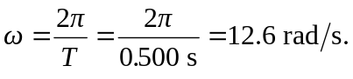 Ground state harmonic oscillator energy is given by
